Instruction on thesis/dissertation upload

Please go to http://etd.ndhu.edu.tw/cgi-bin/gs32/gsweb.cgi/ccd=ooNEEg/webmge?switchlang=en for user guide
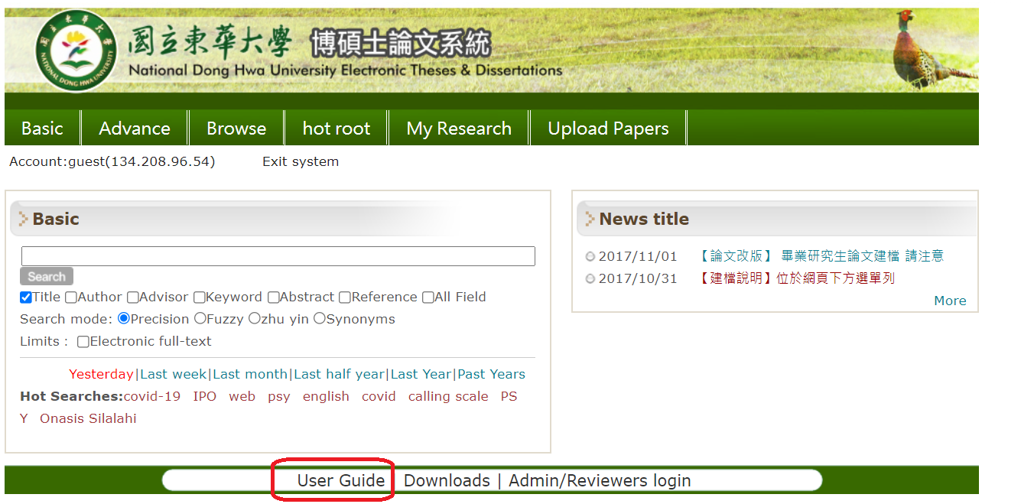

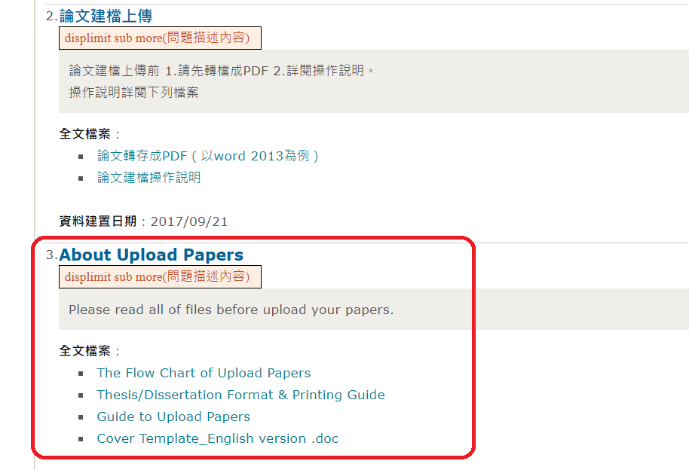

Important note for thesis upload, and thesis online review procedure
1. The content of the PDF electronic file needs to enable search function
2. Use genuine Adobe Acrobat software to convert files to improve the correct PDF format and avoid functional errors.
3. Thesis should be arranged and bound according to the school’s [paper writing and printing format] to avoid rejection. The copy printout’s cover color needs to be 藍色 (Ph.D.) or 灰色（Master）.
4. If there are more than two pages for Acknowledgement, Chinese abstract, English abstract, Table of contents, Table of figures, etc., it can be printed double-sided, but the first page of each part needed to be placed on an odd-numbered page.(when you print out and bind the thesis, the first page of each part has to be bound on the right hand side page）
5. In principle, the “certificate of approval of examination committee” must be bound in between cover and DECLARATION OF THESIS/DISSERTATION ORIGINALITY page. The title of thesis/dissertation should be consistent with the one listed on the “certificate of approval of examination committee”
Download the format of ORIGINALITY page
6. The thesis system’s review process is as follow: 1) the department 2) the library.
Please inform the department office after you uploaded the thesis. You will receive a notification from department office or library informing you the uploaded thesis had been verified or rejected. If it was rejected, follow the instruction from department office or library, revise the thesis and upload it again. The thesis review time is about 1~2 working days for the department office and library, total about 1~4 working days. Please reserve the review time for school leaving procedure.
7. Please only print out the thesis after you received notification from library that your thesis upload had been verified. Please submit 1 copy of hardcopy printout thesis to the department office, and 2 copies to the library, and ask your advisor if he/she needs additional copies.
8.Students need to sign and insert the declaration of thesis/dissertation originality page after certificate page. Download link
9. The library will not accept the submission of thesis for school leaving procedures if the thesis submission had not been approved on system.

Library service division is located in room 197 on the first floor of library.
Tel: 03-890-6842
Email: jms@ndhu.edu.tw

School leaving procedures

The School leaving online procedure system opens during below periods:
*Spring semester: early Jan. ~ mid. Feb.
*Autumn semester: early June ~ mid. Aug.

*If you are graduating during above period:
Please complete the school leaving procedure following below steps:

1) Log in e-portfolio https://sys.ndhu.edu.tw/CTE/Ed_StudP_WebSite/Login.aspx to check if the grades of all courses you took this semester had been registered on the system.

2) Log in the school leaving online procedure system https://sys.ndhu.edu.tw/AA/REG/single/login.aspx to fill out the required info.(all columns needs to show O, if there are columns that shows X, please check with each window to check if there is remaining fees to be paid, or borrowed items to be returned…etc)

3) Fill out below form of “Checklist for departing student”, ask your advisor sign first then go to each windows listed on the form to get stamp to complete the school leaving procedures.

Download Link

*If you are graduating in other months:
Please complete the school leaving procedure following below steps:

1) Log in e-portfolio https://sys.ndhu.edu.tw/CTE/Ed_StudP_WebSite/Login.aspx to check if the grades of all courses you took this semester had been registered on the system.

2.Please fill out below form of “checklist for departing student”, and go to each windows listed on the form to get stamp to complete the school leaving procedures.

Download Link

- Students need print out the form of “checklist for departing student” with their advisor’s signature first then come to department office.
- The last day for leaving campus and obtaining the degree certificate for this semester is February 14th, please inform the department office in advance.
- If you are asking delegate to get the diploma for you from registration division, you need to provide authorization letter, and your ID.
- PhD students need to complete and submit the departmental questionnaire and contact Form.
- Master students need to complete and submit the departmental questionnaire and contact Form.
- educational verification info after you got your certificate: 臺灣花蓮地方法院所屬民間公證人何叔孋事務所 (notaryher.com)
