國立東華大學教育與潛能開發學系
教育博士班 博士論文
Department of Education and
Human Potentials Development,
Doctor of Philosophy Program of Education, NDHU
Doctor of Philosophy Dissertation

指導教授：○○○ 博士
Advisor：○○○, Ph.D

YOUR TITLE

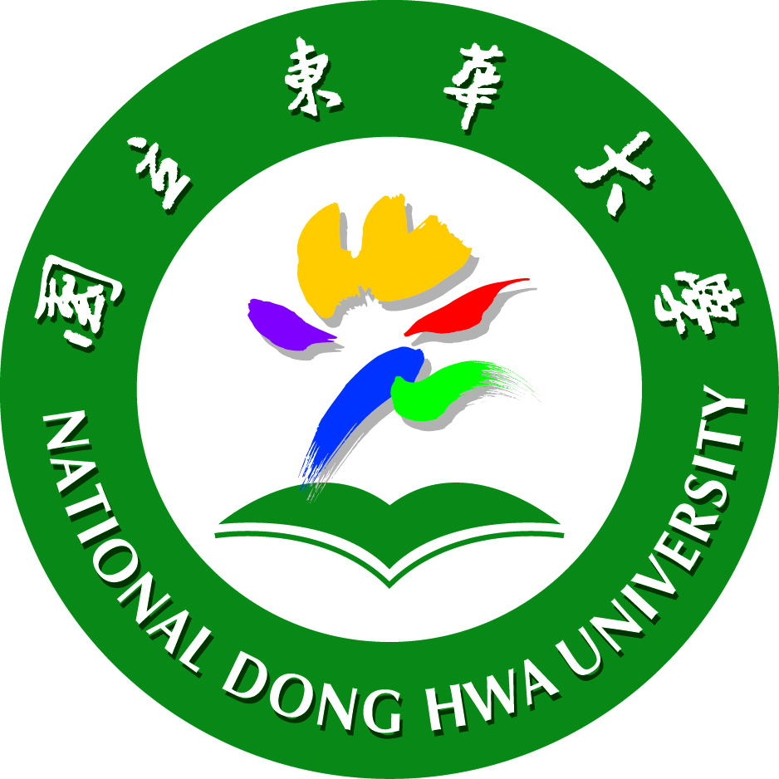

YOUR NAME

中華民國一一四年一月

Janunary, 2025

