國立東華大學教育與潛能開發學系

教育博士班 博士論文

Department of Education and Human Potentials Development

Doctor of Philosophy Program of Education

National Dong Hwa University (NDHU)

**Doctor of Philosophy Dissertation**

YOURITLE YOUR TITLE YOUR TITLE YOUR TITLE YOUR TITLE

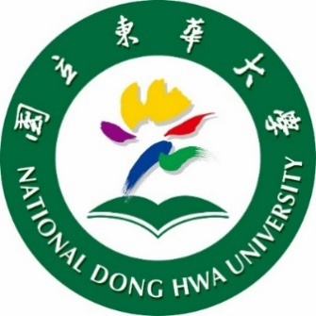

陳達仁碩士

**研究生/ Graduate Student**

Your Name

**指導教授/ Advisor**

Advisor Name

中華民國114年7月

July 2025