國立東華大學教育與潛能開發學系
教育碩士班 碩士論文
Department of Education and Human Potentials Development,
Master Program of Education, NDHU
Master Thesis

[計畫審查Proposal Review]

指導教授：○○○ 博士
Advisor：○○○, Ph.D

YOUR TITLE

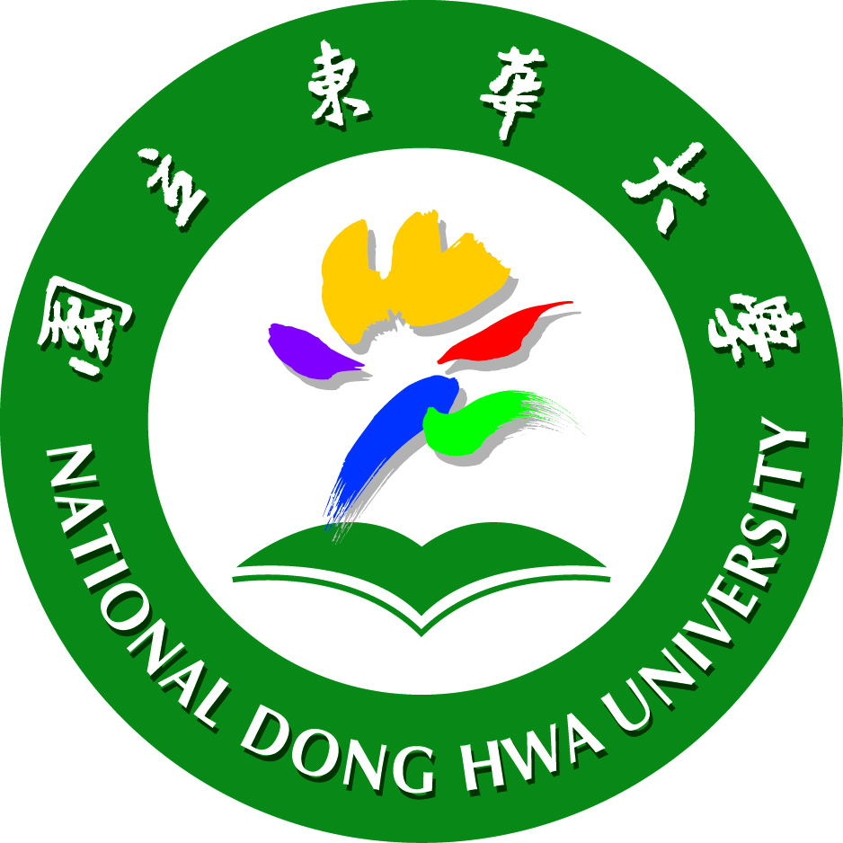

YOUR NAME

中華民國一一四年一月

Janunary, 2025

